Department of Computer Science

Punjabi University Patiala



***ASSIGNMENT OF RELATIONAL DATABASE MANAGEMENT SYSTEM***

***(LAB-III) MCAM-1206L***

*Submitted by-* ***Ishika Garg*** *(21071208),*

***Shairya Sharma*** *(21071225),*

***Ssembuya Abdurahumani*** *(21071291).*

*Submitted to-* ***Dr. Gurpreet Singh Josan, Dr. Sukhjeet Kaur Ranade***

*Course – MCA (Semester - 2nd)*

*Section- A*

*Topic-* ***Management Information System for Online Marriage Bureau***

MARRIAGE BUREAU

The Marriage Bureau ERD is a system where we enables user to register and find his/her ideal match as per their preferences. Here we made ERD 1 of **five (5) entities** with **five (5) relationships** that link each entity to the other.

In ERD 2, there is **one (1) relationship** between two (**2) entities.**

**Here, we describe 2 E-R Models:**

1. **USER ( Registered Person )**
2. **ADVERTISTER ( Who advertise his advertisements on the site )**

**ER DIAGRAM :**

**(with changes as per discussion)**

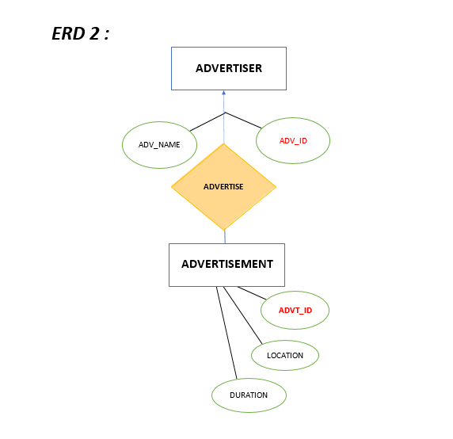

**ERD 1 :**

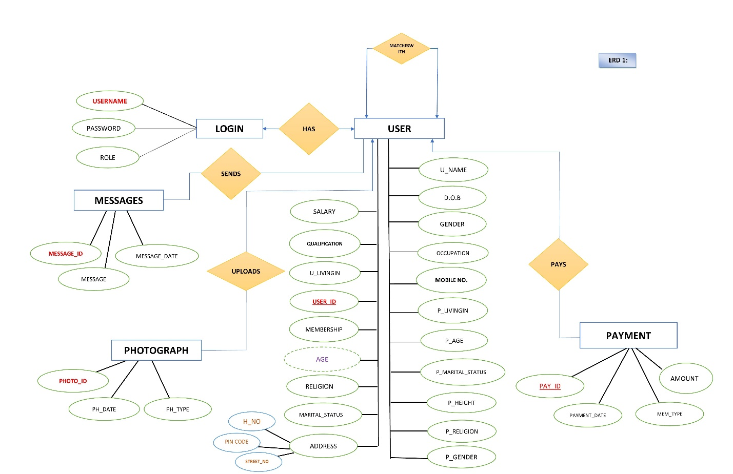

**NORMALIZATION**

Normalization is the process of organizing data in a database. This includes creating tables and establishing relationships between those tables according to rules designed both to protect the data and to make the database more flexible by eliminating redundancy and inconsistent dependency.

In order to comply with the relational model it is necessary to

* Remove repeating groups
* Avoid redundancy and data anomalies by removing partial and transitive functional dependencies.

**TYPES OF NORMAL FORMS:**

Normalization works through a series of stages called Normal forms.

The normal forms apply to individual relations. The relation is said to be in particular normal form if it satisfies constraints.

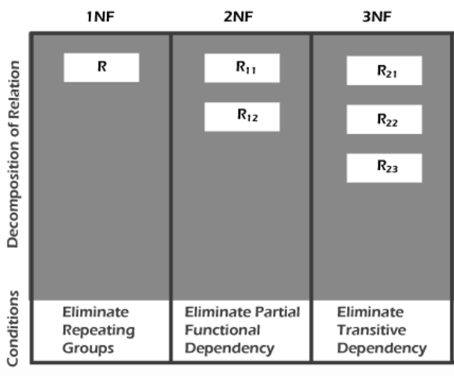

## RELATIONAL MODEL OF ERD 1:

## Final ER Model Nor..jpg

## RELATIONAL MODEL OF ERD 2:

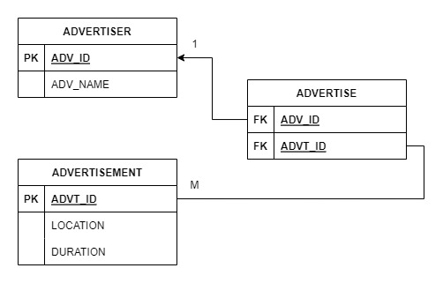

## First Normal Form (1NF)

In the first normal form, only single values are permitted at the intersection of each row and column; hence, there are no repeating groups.

* It should only have single(atomic) valued attributes/columns.
* First normal form disallows the multi-valued attribute, composite attribute, and their combinations.

To normalize a relation that contains a repeating group, remove the repeating group and form two new relations.

In our ER Model how the normalization is done is explained below:-

## ER Model -1:-

# Login Table:-

It is already in 1NF as, it has primary key i.e. **username**, which cannot be repeated it means it has unique values and all the attributes are functionally dependent on the primary key. We cannot insert multiple values in any of the attribute of the login table due to some conditions which means in this table we have atomic values.

# User Table:-

User table is in 1NF, as none of its attribute holds any multiple values; all are containing atomic values even, mobile number having a condition of not repeating any value of it. It also consists of single value which means it is 1 NF.

# Payment Table:-

Payment Table is in 1NF, there is no redundancy in the table and all are containing single valued attribute and we don’t need to make any separate table for this so it is in 1NF.

# Photograph Table:-

Photograph Table is in 1NF, there is no redundancy in the table and all are having atomic valued attributes and we also don’t need to make any separate table for this so it is in 1NF.

# Sends Table:-

It is a relationship b/w user and Messages. It is a combination of both tables primary keys and be used as foreign key in the send table.

# Messages Table:-

Message Table is also in 1NF as, all are containing single valued attribute and don’t have any repeating values in the table. So, we don’t need to make any separate table for this also. So, it is in 1NF.

## ER Model -2:-

# Advertiser Table:-

It is already in 1NF as, it has primary key i.e. **Adv_id**, which does not carry any repeating values it means it has unique value and all the attributes are functionally dependent on the primary key. We cannot insert multiple values in any of the attribute of the advertiser table due to some conditions which means in this table we have atomic values.

# Advertisement Table:-

It is also in the 1NF, as primary key i.e. **advt_id** is not repeating any value and also we have atomic values in this table.

* **It means that our both Relational Model satisfies all the conditions of 1NF.**

* **The Relational Model is in 1 NF.**

## Second Normal Form (2NF)

For the second normal form, the relation is automatically in 2NF if, and only if, the PK (primary key) comprises of a single attribute.

* It should be in the First Normal form.
* And, it should not have Partial Dependency

(*Partial Dependency – If the proper subset of candidate key determines non-prime attribute.)*

## ER Model -1:-

# Login Table:-

It satisfies the 1NF, we don't have any partial dependency because there is only one primary key i.e. username. So, the non-prime attributes i.e. password and role are fully dependent on primary key i.e. username.

# User Table:-

It is in 1NF, it does not contain multiple primary keys. It is holding a single primary key i.e. user-id and other non-prime attributes are fully dependent on user-id.

# Payment Table:-

It satisfies the 1NF, there is not any attribute which is a part of any candidate key. It also holds a single primary key i.e. pay-id and other non-prime attributes are fully dependent on pay-id.

# Photograph Table:-

It satisfies the 1NF, we don't have any partial dependency because there is only one primary key i.e. photo_id. So, the non-prime attributes i.e. ph_date and ph_type are fully dependent on primary key i.e. photo_id.

# Sends Table:-

It is a relationship b/w user and Messages. It is 2NF as, there is no partial dependency occurs.

# Messages Table:-

It satisfies the 1NF, we don't have any partial dependency in this table because there is only one primary key i.e. message_id. So, the non-prime attributes i.e. message and message_date are fully dependent on primary key i.e. message_id.

## ER Model -2:-

# Advertiser Table:-

It satisfies the 1NF, we don't have any partial dependency because there is only one primary key i.e. adv_id. So, the non-prime attribute i.e. adv_name is fully dependent on primary key i.e. adv_id.

# Advertisement Table:-

It is in 1NF, it does not contain multiple primary keys. It is holding a single primary key i.e. advt-id and other non-prime attributes are fully dependent on advt-id.

* **It means that our both Relational model satisfies all the condition of 2 NF.**
* **The Relational Model is in 2NF.**

## Third Normal Form (3NF)

To be in third normal form, the relation must be in second normal form. Also all transitive dependencies must be removed; a non-key attribute may not be functionally dependent on another non-key attribute.

* It should be in the Second Normal form
* And, it should not have Transitive Dependency.

## ER Model -1:-

# Login Table:-

It satisfies the condition it is in 2NF, it is no indirect relation which can cause functional dependency then there is no need to eliminate transitive dependency. Hence, it is in 3NF.

# User Table:-

It is in 2NF, it does not have any transitive dependency because two or more attribute are not indirectly forming any two functional dependency. It is 3NF.

# Payment Table:-

It is in 2NF, there is no attribute which is dependent on another it means there is no transitive dependency occurs so, we don’t need to do change anything. It is in 3NF.

# Photograph Table:-

It satisfies the 2NF, there is no transitive dependency in the photograph table as none of the attributes are dependent on any other. So, it is also in 3NF.

# Sends Table:-

It is a relationship b/w user and Messages.

# Messages Table:-

It satisfies 2NF, it has no indirect relation which can cause functional dependency then there is no need to eliminate transitive dependency. Hence, it is in 3NF.

## ER Model -2:-

# Advertiser Table:-

It satisfies the condition it is in 2NF, it has no indirect relation which can cause functional dependency then there is no need to eliminate transitive dependency. Hence, it is in 3NF.

# Advertisement Table:-

It is in 2NF, it does not have any transitive dependency because two or more attribute are not indirectly forming any two functional dependency. It is 3NF.

* **It means that our both Relational models also satisfy all the condition of 3 NF.**
* **The Relational Model is in 3 NF.**